Assignment 1

keerthi Tiyyagura

2023-09-24

#Setting up the ISLR Package #Giving the install.packages(“ISLR”) command in comments because it’s averting me from knitting to pdf.

library(ISLR)

#Calling the ISLR library

summary(Carseats)

## Sales CompPrice Income Advertising   
## Min. : 0.000 Min. : 77 Min. : 21.00 Min. : 0.000   
## 1st Qu.: 5.390 1st Qu.:115 1st Qu.: 42.75 1st Qu.: 0.000   
## Median : 7.490 Median :125 Median : 69.00 Median : 5.000   
## Mean : 7.496 Mean :125 Mean : 68.66 Mean : 6.635   
## 3rd Qu.: 9.320 3rd Qu.:135 3rd Qu.: 91.00 3rd Qu.:12.000   
## Max. :16.270 Max. :175 Max. :120.00 Max. :29.000   
## Population Price ShelveLoc Age Education   
## Min. : 10.0 Min. : 24.0 Bad : 96 Min. :25.00 Min. :10.0   
## 1st Qu.:139.0 1st Qu.:100.0 Good : 85 1st Qu.:39.75 1st Qu.:12.0   
## Median :272.0 Median :117.0 Medium:219 Median :54.50 Median :14.0   
## Mean :264.8 Mean :115.8 Mean :53.32 Mean :13.9   
## 3rd Qu.:398.5 3rd Qu.:131.0 3rd Qu.:66.00 3rd Qu.:16.0   
## Max. :509.0 Max. :191.0 Max. :80.00 Max. :18.0   
## Urban US   
## No :118 No :142   
## Yes:282 Yes:258   
##   
##   
##   
##

#Printing the summary of the Carseats dataset

View(Carseats)

#It displays the data frame in the viewer to visually inspect the dataset(just used this command for my clarification)

str(Carseats)

## 'data.frame': 400 obs. of 11 variables:  
## $ Sales : num 9.5 11.22 10.06 7.4 4.15 ...  
## $ CompPrice : num 138 111 113 117 141 124 115 136 132 132 ...  
## $ Income : num 73 48 35 100 64 113 105 81 110 113 ...  
## $ Advertising: num 11 16 10 4 3 13 0 15 0 0 ...  
## $ Population : num 276 260 269 466 340 501 45 425 108 131 ...  
## $ Price : num 120 83 80 97 128 72 108 120 124 124 ...  
## $ ShelveLoc : Factor w/ 3 levels "Bad","Good","Medium": 1 2 3 3 1 1 3 2 3 3 ...  
## $ Age : num 42 65 59 55 38 78 71 67 76 76 ...  
## $ Education : num 17 10 12 14 13 16 15 10 10 17 ...  
## $ Urban : Factor w/ 2 levels "No","Yes": 2 2 2 2 2 1 2 2 1 1 ...  
## $ US : Factor w/ 2 levels "No","Yes": 2 2 2 2 1 2 1 2 1 2 ...

#Printing the Structure of the Carseats dataset #This dataset contains 400 observations of 11 variables

head(Carseats,8)

## Sales CompPrice Income Advertising Population Price ShelveLoc Age Education  
## 1 9.50 138 73 11 276 120 Bad 42 17  
## 2 11.22 111 48 16 260 83 Good 65 10  
## 3 10.06 113 35 10 269 80 Medium 59 12  
## 4 7.40 117 100 4 466 97 Medium 55 14  
## 5 4.15 141 64 3 340 128 Bad 38 13  
## 6 10.81 124 113 13 501 72 Bad 78 16  
## 7 6.63 115 105 0 45 108 Medium 71 15  
## 8 11.85 136 81 15 425 120 Good 67 10  
## Urban US  
## 1 Yes Yes  
## 2 Yes Yes  
## 3 Yes Yes  
## 4 Yes Yes  
## 5 Yes No  
## 6 No Yes  
## 7 Yes No  
## 8 Yes Yes

#Printing the first 8 rows of Carseats dataset

max(Carseats$Advertising)

## [1] 29

#Maximum value of Advertising attribute

IQR(Carseats$Price)

## [1] 31

#IQR(interquartile) of Price attribute

plot(Carseats$Sales,Carseats$Price,main = "Running price during the sales",xlab = "Total Sales",ylab="Total Price")  
abline(lm(Carseats$Price~Carseats$Sales),col="Red",lwd=2)

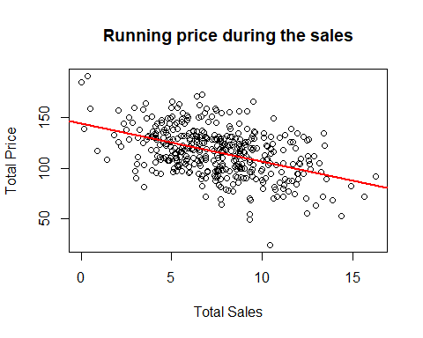 #Scatter Plot of Sales against Price #This Plot shows the regression line of Sales vs Price and it has a negative slope ,implying a negative correlation ,and the value ranges from 0 to -1 #Also here we can observe that the regression line’s quality of fit with points is good

correlation<-cor.test(Carseats$Sales,Carseats$Price,method="pearson")  
correlation

##   
## Pearson's product-moment correlation  
##   
## data: Carseats$Sales and Carseats$Price  
## t = -9.912, df = 398, p-value < 2.2e-16  
## alternative hypothesis: true correlation is not equal to 0  
## 95 percent confidence interval:  
## -0.5203026 -0.3627240  
## sample estimates:  
## cor   
## -0.4449507

#Calculating the correlation of two attributes #The correlation coefficient value is -0.444,it is indicating a negative direction.If one variable increases and other variable decreases the strength of the relationship will be moderate.